Project Title: Water Refilling Station Management System
Business: 5J CABALUNA Water Refilling Station
Business Problem: The business uses paper to write customer and order records. This can cause lost records, mistakes, and slow searching.
How the system solves these Problems: The system helps the business keep customer and order records on the computer. It makes searching, updating, and managing information faster and easier. It also helps keep the records organized.
ERD (Entity Relationship Diagram)
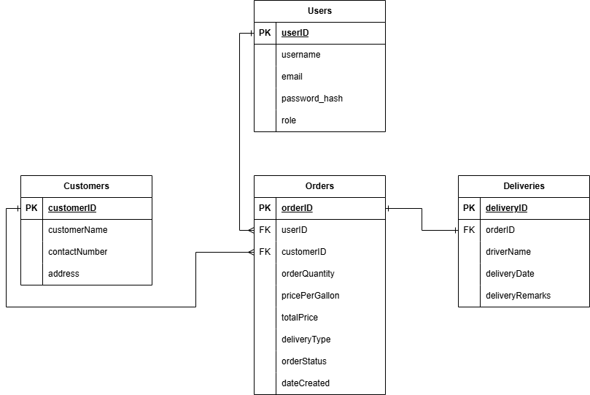

User → Orders (1:N)
One user can add many orders. Each order is added by only one user.
Customer → Orders (1:N)
One customer can have many refill orders. Each order belongs to only one customer.
Order → Delivery (1:1)
One order has one delivery record. Each delivery record belongs to only one order

Features:
- Authentication
- Register
- Login
- Logout
- Password Hashing
- Dashboard
- View total customers
- View total orders
- View total deliveries
- View total sales
- View recent orders
- Customer Management
- Add customer
- View customers
- Search customer
- Edit customer
- Delete customer (Admin only)
- Order Management
- Add order
- View orders
- Search order
- Edit order
- Delete order (Admin only)
- Deliveries
- View delivery records
- Search driver
- Reports
- View total customers
- View total orders
- View deliveries
- View pickup orders
- View total sales
- View recent orders
- User Management
- View users
- Search users
- Change user role
- Delete user (Admin only)
- User Roles
- Admin
- Full access
- Manage users
- View reports
- Delete records
- Staff
- Manage customers
- Manage orders
- View deliveries
- Cannot view reports
- Cannot manage users
- Cannot delete records

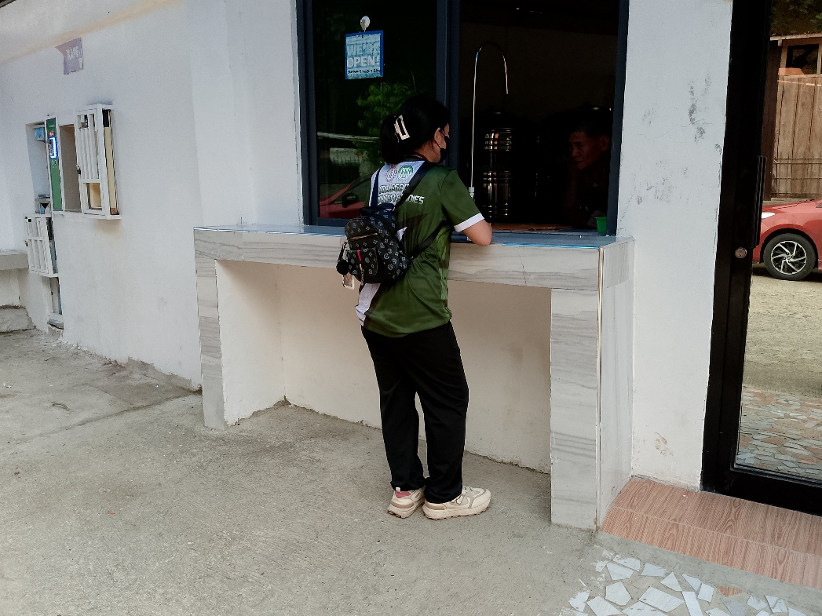
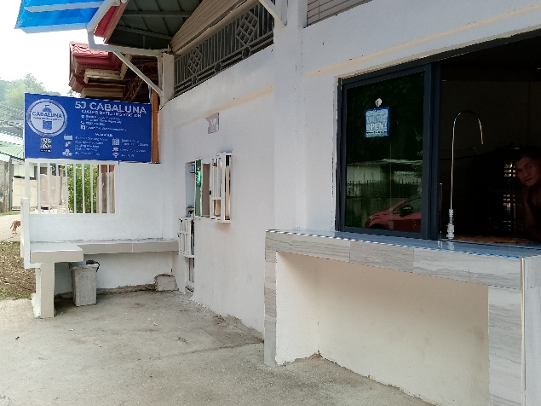
DOCUMENTATION

